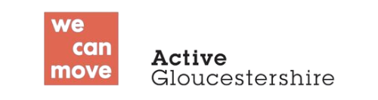
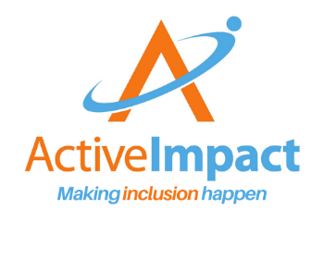

Inclusive Activities Award – Gloucestershire
Organisation Name:
Application

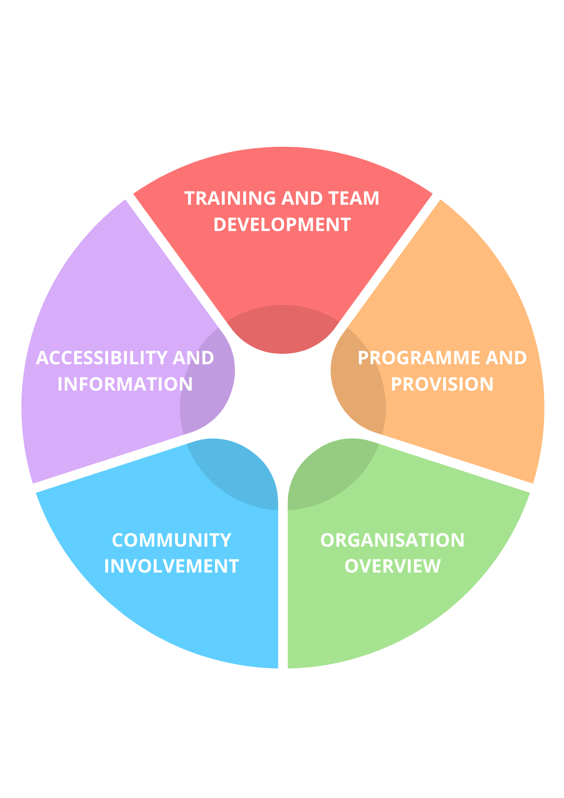
Inclusive Activities Award – Development Areas
Each section has a self-scoring grid for each target or requirement
not yet actioned working towards requirement has been met
Inclusive Activities Award Check list
Organisation Overview
Focus Area
Safeguarding Policy
Safer Recruitment (staff and volunteers)
DBS Checks
Health and Safety Policy
Risk Assessments
Public Liability Insurance
Professional Indemnity Insurance
Inclusion Policy
Other relevant Policies e.g behaviour, medication, volunteer/staff conduct
Action Plan
What/who/how? | Target date
What evidence have you prepared?

Organisation Overview - Evidence
You will be asked to confirm some basic information about your group’s operational processes such as:
Safeguarding
Health and Safety
Insurance
Policies and Procedures

Evidence – can be written or In other formats, or presented as part of a Q&A session with assessors:
Show us your website or printed information and demonstrate how it covers inclusion and shares useful accessibility information/commitment to meeting disabled people’s reasonable adjustments.
Show us your profile and Thing to Do listing on You’re Welcome Gloucestershire
Show us examples of your social media and how it is accessible to screen reader users and deaf people (alt text and captions)

Accessibility and Information
Focus Area
We regularly complete accessibility reviews
We can demonstrate ways we have improved our accessibility
We provide accessibility information in advance
Our team know where to find accessibility information
We have a video and/or photos of our venues available in advance
We have a profile and at least one ‘Things to Do’ listing on You’re Welcome Gloucestershire
We share information about what to expect in advance
Our information contains:
All important information as text (not just a poster/image)
Multiple ways to get in touch
Descriptions of our venue accessibility and possible adaptations
Details of access points, drop off zones, parking, public transport
Is written in clear simple wording
Has alt text descriptions of any images
Videos have captions
Videos have audio description (can be part of the dialogue)
Action Plan
What/who/how? | Target date
What evidence have you prepared?

Evidence – can be written or In other formats, or presented as part of a Q&A session with assessors:
training portfolio
case studies
examples of how you share good practice, ideas and information with your team
evidence of good practice and areas of development from the past 12+ months

Training and Team Development
Focus Area
2+ staff have completed one or more of the following training:
Inclusion Needs You – via Active Impact
Inclusive Communications – via Active Gloucestershire
relevant coaching training
other relevant training
Team members have opportunities to observe good practice
Inclusive practice and accessibility is part of staff meetings
Inclusive practice and accessibility is part of strategic planning
Inclusive practice and accessibility is part of staff induction
Inclusive practice and accessibility is part of staff supervision
Disabled people have opportunities to be part of the team
Disabled people have opportunities to progress their skills/career
Team members attend network meetings regularly
There is an inclusion champion/coordinator in the team
Action Plan
What/who/how? | Target date
What evidence have you prepared?

Evidence – can be written or in other formats, or presented as part of a Q&A session with assessors:
Examples of your programme on website/ You’re Welcome Gloucestershire, flyers
Observations of activities as part of our visits
Case studies/presentations about good inclusive practice.

Programme and Provision
Focus Area
Our programme:
Has been reviewed using STEPS and the Inclusion Spectrum
includes choices of activity as part of our regular offer
Can be accessed flexibly where possible
Enables disabled and non-disabled people to participate together
Is developed using community feedback
Our provision includes:
A good welcome and induction for participants
A safe space/break out area
Reasonable adjustments to session location/length/content
Makes use of staff and volunteers to increase ratios where needed
Is reviewed regularly based on community feedback
Action Plan
What/who/how? | Target date
What evidence have you prepared?

Evidence – can be written or in other formats, or presented as part of a Q&A session with assessors:
evidence of good practice and areas of development from the past 12+ months

Community Involvement
Focus Area
Disabled people can hold various roles in our organisation
We can identify ways we are increasing disabled people’s roles
We ask for community feedback regularly
We have processes to help us understand community needs
We have reviewed how and where we seek feedback
We have considered who isn’t coming/ no longer comes
We take action to engage people we haven’t reached before
We can evidence how we have embedded participation
Action Plan
What/who/how? | Target date
What evidence have you prepared?

