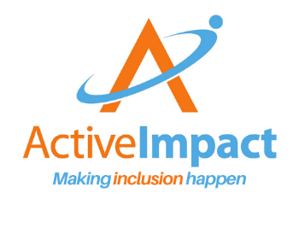
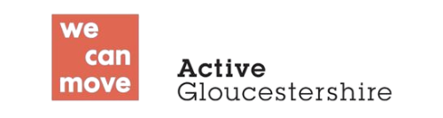
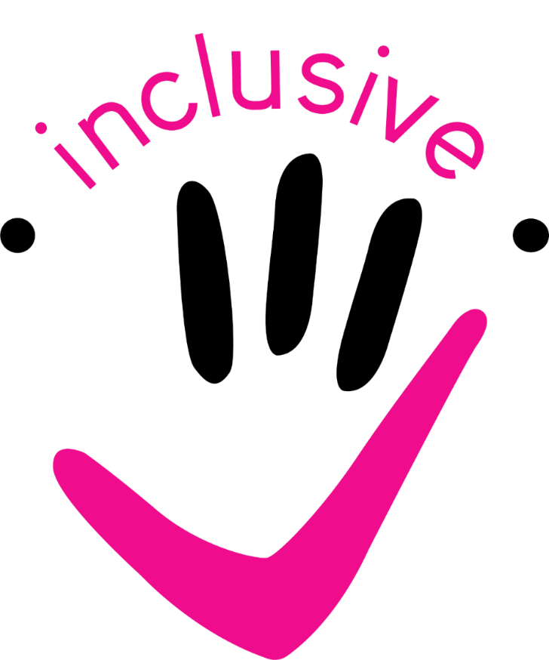
Inclusive Activities Award – Gloucestershire
Handbook
What is the Inclusive Activities Award – Gloucestershire?
The Inclusive Activities Award – Gloucestershire is designed to help local community groups, clubs and activity providers to develop their inclusive practice so that they can welcome disabled children - and then gain public recognition for their commitment to inclusion.
The Award has been developed by Active Impact and Active Gloucestershire collaboratively. Both organisations support activity providers through the provision of training, networking and developmental guidance. This Award is a way to record and celebrate the inclusive developmental actions taken by activity providers through their involvement in these support opportunities.
Whilst holding the Award cannot be a guarantee of quality, those organisations granted the Award will have shown a genuine commitment to be inclusive.

Who can apply for the Inclusive Activities Award?
To be awarded, your organization must provide opportunities that are inclusive. This means that disabled and non disabled people can participate together in some manner within the provision.
If you are a specialist/dedicated disabled people’s provide you can apply, but you need to be clear how you ensure there is non-disabled participation or involvement in the wider community.
This Award is aimed at provision for young people up to age 25. If you are an all age provider you can apply as long as you offer something for young people under 25 (this could be 18+).
You must be based in Gloucestershire or on our borders with Gloucestershire residents attending your activities.
You could be a voluntary group, a non-profit organization or a local business.
You could be a sports or creative venue rather than an activity provider.

What sort of commitment is required?
We want organisations to sign up because they think that including disabled people is important and because they intend to take some action to enhance their inclusive practice. We don’t want the process to be so costly in terms of time or money that it prevents good, welcoming organisations from being recognised as such. This process should fit into your organisation’s wider ongoing quality assurance and development. We will meet with you at least three times; two of these meetings can be online, and we will visit in person at least once.
There are five areas we will look at together (see page 5) these will all be elements of your organisation’s operations, meaning that you will already be regularly reviewing and improving these aspects of your organisation. We will be looking for evidence of regular, ongoing commitment to ensure that what you offer is inclusive of disabled people.
You can demonstrate your current and planned actions in each of the five areas in a variety of ways. For example, as part of an interview or presentation with Q&A by our assessors, or as a portfolio of resources/case studies using the Checklist and Action Plan as a record of progress made.
We will visit you, ask for community feedback, agree ongoing actions or targets and then confirm the award when we see progress toward those targets.

How will you benefit from achieving the Inclusive Activities Award?
Access to training and inclusion support:
Active Impact and Active Gloucestershire offer free or low cost training and inclusion support for organisations who provide children’s activities in Gloucestershire. You will be part of our proactive inclusion networks to help you keep up to date on the latest funding, training and other opportunities.
Free promotion of your activities to a wide audience in Gloucestershire:
As part of the Award you will be supported to list your activities on www.yourewelcomeglos.org the YW Glos team will then promote your activities to families in Gloucestershire through social media, newsletters and in partnership with Gloucestershire Parent Carer Forum and Glos Families Directory.
Recognition of your commitment when applying for funding:
Gaining the Inclusive Activities Award and listing your offer on You’re Welcome are both great ways to demonstrate to funders that you are committed to being inclusive of disabled people. Gloucestershire County Council, Gloucestershire ICB, Barnwood Trust and Gloucestershire Disability Fund all look for evidence of this commitment when awarding funding.

What happens in the Inclusive Activities Award Application Process?
We will meet with you to explain a bit more about the award and the development areas we will be looking at. We will provide you with the handbook that contains a checklist, resources and action plan. This will help you review your current inclusive practice in the four areas, identify areas of development and set targets, then complete your evidence. Remember this is a way of recording a lot of what you are already doing as well as identifying areas of development, so you will already have some of the information from your day to day operational records.
You can use the Checklist and Action Plan to submit evidence - they are a helpful way to ensure you cover all the necessary areas. If you prefer you can demonstrate your evidence in a series of Q&A sessions with the assessor team.
We will ask to meet a disabled participant and get their feedback or alternatively, we will arrange for a disabled guest to attend your activity and provide feedback.
We will combine your evidence and the participant feedback, and use this to make a decision on whether you have enough evidence to receive the award. We may set some additional targets if we feel there are areas that need significant development.
Once the award is agreed we will continue to provide support, training and networking opportunities. We might also ask you to share your experiences of the award with new applicants.

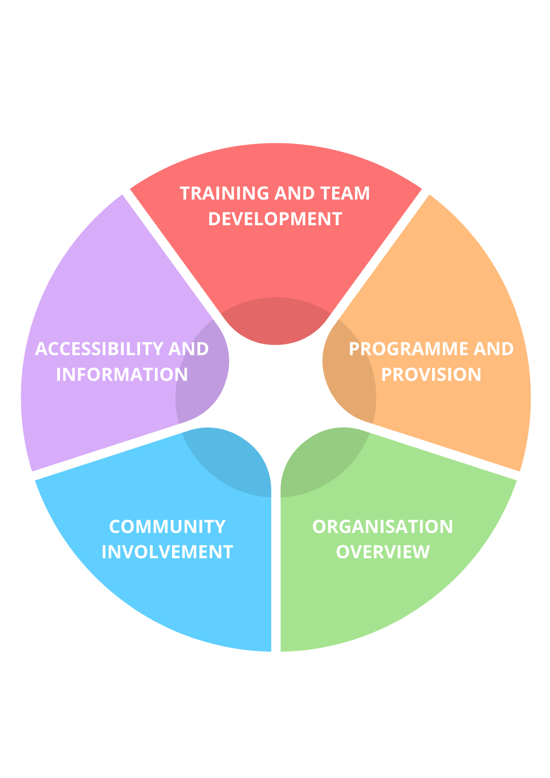
Inclusive Activities Award – Development Areas
Each section has a self-scoring grid for each target or requirement
not yet actioned working towards requirement has been met
Inclusive Activities Award Check list
Organisation Overview
Focus Area
Safeguarding Policy
Safer Recruitment (staff and volunteers)
DBS Checks
Health and Safety Policy
Risk Assessments
Public Liability Insurance
Professional Indemnity Insurance
Inclusion Policy
Other relevant Policies eg behaviour, medication, volunteer/staff conduct
Action Plan
What/who/how? | Target date
What evidence have you prepared?

Organisation Overview - Evidence
You will be asked to confirm some basic information about your group’s operational processes such as:
Safeguarding
Health and Safety
Insurance
Policies and Procedures

Resources for Inclusive Policies and Procedures
If you belong to an umbrella organisation or have an advisor, they may have an equalities policy and procedure that you could look at. If you are updating or writing new policies involving disabled participants, ask for their feedback and ideas on what would help make your offer more inclusive.
This is a helpful resource for understanding the Equalities Act 2010 and the legal requirement to make reasonable adjustments for disabled people:
https://www.scope.org.uk/advice-and-support/disability-discrimination-by-private-and-public-service-providers
This example is from the Scout Association: https://www.scouts.org.uk/por/2-key-policies/21-equal-opportunities-policy/
Remember to use factual language and ensure disabled people as a demographic group are highlighted within key policies such as:
Equality/diversity, membership, inclusion, safeguarding, travel, training and employment policies.
British Rowing Guide about making clubs more inclusive which covers all types of people who may feel excluded: https://www.britishrowing.org/wp-content/uploads/2018/03/British-Rowing-Inclusive-Club-Guide-2018.pdf
Sport England has a helpful Toolkit: Being inclusive | Buddle
Safeguarding – a list of links to local and national Safeguarding Resources
http://www.activeimpact.org.uk/see/uploads/Safeguarding-Resources-with-links.pdf

Accessibility and Information
Focus Area
We regularly complete accessibility reviews
We can demonstrate ways we focus on improving our accessibility
We provide accessibility information in advance
Our team know where to find accessibility information
We have a video and/or photos of our venues available in advance
We have a profile and at least one ‘Things to Do’ listing on You’re Welcome Gloucestershire
We share information about what to expect in advance
Our information contains:
All important information as text (not just a poster/image)
Multiple ways to get in touch
Descriptions of our venue accessibility and possible adaptations
Details of access points, drop off zones, parking, public transport
Is written in clear simple wording
Has alt text descriptions of any images
If used - videos have captions
If used - videos have audio description (can be part of the dialogue)
Action Plan
What/who/how? | Target date
What evidence have you prepared?

Accessibility - Suggested actions:
Demonstrate understanding of the accessibility in venues you use/operate and utilise best practice around describing/showing the access through images, video and written descriptions so individuals can decide if it meets their requirements.
Walk around your venue/sites (2 or more people, preferably including a disabled participant) and check:
- Designated parking, nearby parking/drop off area
- Public transport links or buddy lift schemes
- Sufficient space to navigate in a wheelchair
- Items and work surfaces are at the right height for wheelchair users
- Consider ramps, rails, accessible toilets
- Adapted equipment as required
- Range of seating options
- Sensory impact of lighting, sounds, smells
- Availability of quiet/chill out space
- Safety measures if someone attending is at risk of leaving/self-harming
- Where barriers exist (eg stairs with no alternative access), consider offering outreach at an alternative venue if someone requests this.
- Think about safety and general information being clearly displayed - easy read pictures - not just words, braille/large print.
Evidence - Show us where key information about your venue is available to participants in advance and demonstrate that team members know how to signpost to this and are familiar with the content.
Information - Suggested actions:
Share key information about activities in advance that enables disabled people to feel they would be welcome and that their requirements could be accommodated/they could ask for accommodations including:
- Describe the physical access at venues you use/operate and any adaptations you can make.
- Share images and/or a video of venue so people know what to expect.
- Identify access points, drop off zones, parking, local public transport.
- Name Inclusion Champion (if there is one) on website.
- Make it clear you welcome people getting in touch to discuss specific requirements/ask questions about how they can be included.
- Include text of details when sharing a poster (do not have all the key info just in an image).
- Use positive imagery of disabled people. Include images that reflect our diverse society and invite people to ‘see themselves there’.
- Ensure information is shared in accessible format:
- Add alt text to images on social media, newsletters and website.
- Make language clear and accessible with an easy read version available where appropriate.
- Caption videos and provide audio description.
- Consider adding BSL versions of key information (ask for suggestions of where to get funding for this).
- Ensure your FAQs include accessibility information or a clear link to this.
Evidence – can be written or In other formats, or presented as part of a Q&A session with assessors:
Show us your website or printed information and demonstrate how it covers inclusion and shares useful accessibility information/commitment to meeting disabled people’s reasonable adjustments.
Show us your profile and Thing to Do listing on You’re Welcome Gloucestershire
Show us examples of your social media and how it is accessible to screen reader users and deaf people (alt text and captions)

Accessibility and Information Resources
The ‘Does our Venue Enable Everyone to Take Part?’ Top Tips Resource gives more ideas about reviewing accessibility at your venue. By answering the questions your team can do a light touch audit of the space you work in and begin to plan for any improvements required or actions you need to take.
https://www.activeimpact.org.uk/see/uploads/Top-Tips-Series-Does-our-venue-enable-everyone-to-take-part.pdf
Some good local examples:
https://aerospacebristol.org/accessibility
https://www.museumofgloucester.co.uk/your-visit/accessibility
Active Alliance has a free inclusive communication guide available online: https://www.activityalliance.org.uk/how-we-help/resources/60-inclusive-communications-guide
The Activity Alliance’s ‘Access for all: Opening Doors’ guide is designed for sports clubs but offers useful general advice on improving physical access for disabled people. https://www.activityalliance.org.uk/assets/000/000/045/Access_for_all_November_2015_original.pdf?1457371169
Think about accessible communication. This may include British Sign Language videos, large print and easy read. Ensure your website has accessibility settings including ‘alt text’ to explain the content of any images to users accessing it via a screen reader. If you would like more information, contact www.eye4detail.org
An inclusion statement can be as simple as: ‘We welcome people from all cultures and backgrounds, including those who are disabled. We will make whatever reasonable adjustments we can to ensure that everyone is safe, welcome and able to take part.’ The key is to mean what you say. To create a more detailed inclusion statement, ask Active Impact for their guidance on ‘Writing an Inclusion Statement’.
Stock images of disabled people vary in quality. Where possible use photos from your setting which reflect the diversity of your participants and show disabled people taking an equal part in activities.
Alternatively contact https://www.inclusiongloucestershire.co.uk/ who may be able to share positive imagery from their user led drama/film group.
Sign your organisation up to the You’re Welcome Gloucestershire (YW Glos) Inclusive Online Community Website. It’s a great place to share your inclusive activities with people in Gloucestershire. The You’re Welcome team can support you in making sure your information is clear and accessible and, once you receive your Inclusive Award, you can include the award in your listing. To get help from the team email hello@yourewelcomeglos.org.
Glosfamiliesdirectory.org.uk lists services and activities for families with children aged 0-25. It includes the ‘Local Offer’ for families of disabled children and young people where organisations can share information about their inclusive activities.
If your services are for adults you can list them on www.yourcircle.org.uk.
Gloucestershire Deaf Association www.gda.org.uk offers BSL video translation services. Inclusion Gloucestershire http://www.inclusiongloucestershire.co.uk can offer advice on creating Easy Read versions of any information.
The terms ‘disabled and non-disabled’ to describe people reflect the ‘Social Model of Disability’. Choose language that is factual and reflects your organisation’s beliefs. Learn more about the Social Model of Disability on the Scope Website.
Training and Team Development
Focus Area
2+ staff have completed one or more of the following training:
Inclusion Needs You – via Active Impact
Inclusive Communications – via Active Gloucestershire
Inclusive Activities Programme – Via Active Gloucestershire
relevant coaching training
other relevant training
Team members regularly observe and highlight good practice
Inclusive practice and accessibility is part of staff meetings
Inclusive practice and accessibility is part of strategic planning
Inclusive practice and accessibility is part of staff induction
Inclusive practice and accessibility is part of staff supervision
Disabled people have opportunities to be part of the team
Disabled people have opportunities to progress their skills/career
Team members attend network meetings regularly
There is an inclusion champion/coordinator in the team
Action Plan
What/who/how? | Target date
What evidence have you prepared?

Training and Team Development - Suggested actions:
Ensure inclusion and relevant associated topics are part of staff induction and ongoing development and training:
REQUIRED TRAINING: Inclusion Needs You and/or Inclusive Activities Programme (from Activity Alliance via Active Gloucestershire), Inclusive Communications, coaching qualifications (if applicable)
DESIRABLE TRAINING: understanding specific conditions (eg Deaf Awareness, Autism/ADHD/Neurodivergence), care skills (eg feeding, intimate care etc), using other communication methods (eg British Sign Language, Makaton, AAC), behaviour support, mental health support.
Support staff to gain specific skills to provide assistance if someone has specific requirements (this could be by visiting another setting to learn from them or more formal training)
Provide opportunities for disabled people to work or volunteer in the organisation with appropriate support. Ensure disabled team members are able to access career development opportunities.
Include accessibility and inclusive practice, and share good practice in general as topics in staff meetings/strategic planning/supervisions.
Regularly attend network meetings or other development opportunities with a focus on inclusive practice eg GAIN, Aiming High, Partnership Boards.
Consider an inclusion champion/coordinator role that is about embedding inclusive practice across the team (not just handling all disabled people’s enquiries without input from others).

Evidence – can be written or In other formats, or presented as part of a Q&A session with assessors:
training portfolio
case studies
examples of how you share good practice, ideas and information with your team
evidence of good practice and areas of development from the past 12+ months
Training and Team Development Resources
Further information about local training can be found at:
https://www.yourewelcomeglos.org/training
www.glosfamiliesdirectory.org.uk/trainingandsupport
https://www.activeimpact.org.uk/inclusion-needs-you-training/
For physical activity leaders: http://www.activityalliance.org.uk/how-we-help/training/inclusive-activity-programme
This free online training course offers lots of useful information about the key issues faced by disabled people. It is a healthcare based course but anyone can register and complete the training. https://www.disabilitymatters.org.uk/
‘The Busker’s Guide to Inclusion’ has just released a second edition with the first edition having been reprinted over 5 times and sold over 15,000 copies. It is available via Active Impact or on Amazon. This is a short guidebook full of useful information to consider and act upon.

Programme and Provision
Focus Area
Our programme:
Has been reviewed using STEPS and the Inclusion Spectrum
includes choices of activity as part of our regular offer
Can be accessed flexibly where possible
Enables disabled and non-disabled people to participate together
Is developed using community feedback
Our provision includes:
A good welcome and induction for participants
a safe space/break out area
reasonable adjustments to session location/length/content
Makes use of staff and volunteers to increase ratios where needed
Is reviewed regularly based on community feedback
Action Plan
What/who/how? | Target date
What evidence have you prepared?

Programme and Provision - Suggested actions:
Demonstrate how your programme is delivered in terms of accessibility and inclusive practice eg:
Case studies of adaptions using STEPS model (see resources).
Offer choices as part of your regular practice so its not seen as unusual.
Work with other organisations to offer opportunities you could not deliver inclusively on your own (like specialist water sports providers etc).
Show which parts of the Inclusion Spectrum are reflected in your programme.
Open - Modified - Parallel - Separate/Alternative - Dedicated/Specialist
If all activities are specialist, can you join up socially with the wider community? If your activities are competitive, this could be warm ups, skills, or training for everyone together.
NB If you are a specialist disabled service provider you will need to show how you ensure a mix of disabled and non-disabled people participate in at least some of your provision.
Offer opportunities for disabled people to take part in wider community events as participants, audience, leaders, volunteers, mentors, staff, etc
Show how your provision is inclusive through:
A good welcome and induction is available for new participants. They have enough time to get ready, learn new skills, make progress (where applicable).
Choice of venue, activities, provision of safe space/break out areas, length of sessions, tasters, staffing/volunteer ratio – use of extra team members to facilitate inclusion.
Regularly reviewing your offer and asking for feedback on what could be added to increase inclusive practice.
If you have a new participant who has specific requirements, be open and ready to review your procedures if any of them present a barrier to their participation. Remember to ask the participant or their family about what they would like to do and what adaptions might be needed to enable their involvement. This might include actions like reviewing Fire evacuation plans, or thinking about the way a session is timetabled or organised in terms of group sizing.
Evidence – can be written or in other formats, or presented as part of a Q&A session with assessors:
Examples of your programme on website/ You’re Welcome Gloucestershire, flyers
Observations of activities as part of our visits
Case studies/presentations about good inclusive practice.

Programme and Provision Resources
Read about the STEP model for adapting activities here:
https://www.activityalliance.org.uk/get-active/at-home/adapting-activities
https://www.activityalliance.org.uk/assets/000/003/442/STEP_tips_for_disabled_people_families_and_friends_original.pdf
View the STEP model, Inclusion Spectrum and lots of other great resources on Active Impact’s website:
https://www.activeimpact.org.uk/online-inclusion-resources/
This guide contains lots of great inclusive games for children:
https://www.activeimpact.org.uk/see/uploads/lets-play-together.pdf
This NHS guide has some simple ideas of accessible activities:
https://www.nhs.uk/healthier-families/activities/accessible-activities/
Great resources on developing your organisation’s overall inclusive practice:
https://www.mencap.org.uk/sites/default/files/2016-06/TOOLKIT-NI.compressed.pdf
Community Involvement
Focus Area
Disabled people can hold various roles in our organisation
We can identify ways we are increasing disabled people’s roles
We ask for community feedback regularly
We have processes to help us understand community needs
We have reviewed how and where we seek feedback
We have considered who isn’t coming/ no longer comes
We take action to engage people we haven’t reached before
We can evidence how we have embedded participation
Action Plan
What/who/how? | Target date
What evidence have you prepared?

Community Involvement - Suggested actions:
Demonstrate what roles do, or could, disabled people hold in your organisation.
Outline what steps you are taking to increase disabled people’s involvement at all levels of your organisation.
Consider:
Are you asking for community feedback regularly?
Have you reflected on how and where you are gathering feedback from?
What steps do you take to understand participants’ experiences? (see resources for potential user experience feedback sheet).
How do you identify the needs of your community?
How do you identify who isn’t coming/has stopped coming? What do you do with that information?
How have you embedded participation?
Evidence – can be written or in other formats, or presented as part of a Q&A session with assessors:
evidence of good practice and areas of development from the past 12+ months

Community Involvement – Resources
Coproduction
https://www.coproductioncollective.co.uk/championing-co-production/the-value-of-co-production
https://www.disabilityrightsuk.org/resources/co-production-narrative

Participation
https://councilfordisabledchildren.org.uk/resources/all-resources/filter/participation/voice-influence-and-engagement-guide

Find local volunteers here: https://www.govolunteerglos.org/
Glos VCS Alliance has guidance for Trustees:
https://www.glosvcsalliance.org.uk/what-we-do/vcse-sector-resources
Assessment Questions
These are the broader themed questions we will be asking ourselves when we review any written evidence submitted. They would also form the basis of a Q&A session with any applicants who prefer to complete their assessment through a presentation/series of meetings.

Accessibility and Information:
What reasonable adjustments have you made/planned to ensure disabled people can get into and around your facility?
What reasonable adjustments have you made/planned to enable disabled people to join in/use the equipment?
Have you asked disabled people what access changes would be helpful?
How does your organisation make it clear that it is inclusive?
How do you ensure disabled people know what you are doing and that they can take part?
Are positive representations of disabled people included in your publicity?
Is the information you share accessible for people who require captions, screen readers, simple language, visual guides?

Training and Team Development:
Who within your organisation has undertaken inclusion training?
What evidence do you have that colleagues share your enthusiasm for inclusion?
Do leaders demonstrate positive attitudes towards disabled people?
Is Inclusion discussed at staff/team meetings and individual supervision using various evaluation techniques?
Do staff/leaders consider the language they use and the approach they take to activities to be more inclusive?
Who within your organisation (which staff/roles) have been involved in discussing the areas covered by this application form?
Programme and Provision:
How do you ensure the activities that are part of your programme are inclusive? Can you use the STEPs model and Inclusion Spectrum to demonstrate this?
Do you offer a range of opportunities and build in choice to your regular plans?
Do you include disabled people in open/universal activities and/or offer dedicated provision?
If your programme offers dedicated provision specifically for disabled people only, how are disabled participants included in the wider life of your organisation?
How do/would you organise support and assistance for individual disabled people from appropriate people within or beyond your own team if required?

Community Involvement:
How do you check out whether inclusion is working well? Who do you do this with?
What evaluation happens at the end of sessions/events and how do you gather feedback?
How do you involve disabled participants in your reviews? Do you offer a range of ways to engage in the process and give feedback - including verbal, written, anonymous?
Do you offer opportunities for disabled people to be involved in all levels of your organisation, eg participant, volunteer, leader, Trustee, mentor?

